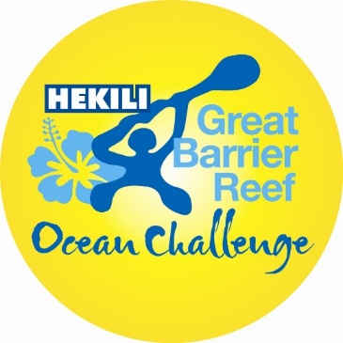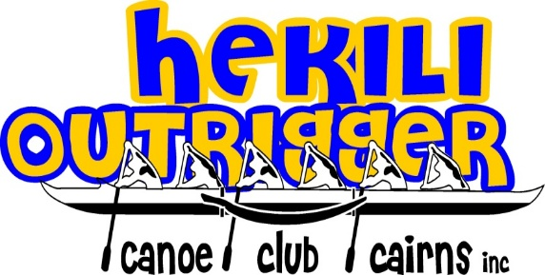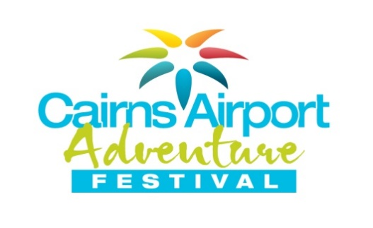

www.hekilioutrigger.com.au

HEKILI OUTRIGGER CANOE CLUB

Are proud to present the Sixth

Great Barrier Reef Ocean Challenge

Sunday 5th June, 2016
45km Downwind race
Yorkey’s Knob to Port Douglas
IRON
Start time: 9:30AM
OC1/OC2/OC6, Surf Skis, SUPs and Prones

Australia’s longest iron distance ocean race…
…. if it was easy, everyone would do it!

GBROC is a part of the 2016 ‘Cairns Airport Adventure Festival’ commencing on Sunday, 5 June, culminating on Sunday, 12 June with the Cairns Airport Ironman Cairns triathlon. This is an action packed sporting festival featuring some of the world’s elite sportsmen and women. Be part of the action as Tropical North Queensland provides the ultimate location for grueling distance and fantastic surf action.

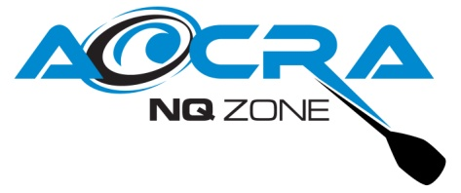
THE VENUE and THE COURSE…….there’s something different here!

Welcome GBROC’ers – here’s the plan for 2016.

Every vessel participating needs to have a mobile phone with the SafeTrx App downloaded and activated. This will be used on the day to assist with safety of vessels. Further information will be provided on our webpage shortly.

All competitors will complete a 45 km course, commencing from Yorkey’s Knob Main Beach, 18km north of Cairns. The start line will be set between two buoys in front of the rock wall at the northern end of Yorkey’s Knob Main Beach. The course gives all competitors a continuous downwind run and should make for some fast times and exciting racing. Crews should anticipate average race times of between 3 and 5 hours. Any competitors who have not completed the course within 5.5 hours will be asked to withdraw from the race.

All competitors will paddle NNW (340’) rounding the Southern side of Haycock Island, keeping Double Island on the left for 10.2km (5.5nm). Canoes will then head NW (315’) direct to Port Douglas.

Paddlers will continue for the next 12.3km (6.6nm) on a north westerly heading.

All crews have permission to paddle direct to Port Douglas and are able to paddle outside of the EPIRB exclusion zone of 2 NM, provided they have the SafeTrx active and login information has been made available to the GBROC Race Manager.

The large buoy north of Alexandra Reefs will mark the final 3 km (1.4 nm) leg into Four Mile Beach, Port Douglas. Crews commence their approach to the finish line by passing between two buoys directly in front of the Port Douglas Surf Life Saving Club on the northern end of Four Mile Beach.

The Finish Line is the Cairns Airport Adventure Festival Archway on the beach.

It is anticipated that paddlers will finish between approximately 12:40pm and 2:40pm. The infamous RRR Mountain Bike Challenge and Coral Coast Triathlon will also conclude on Four Mile Beach as part of the celebration of the opening day of the Cairns Airport Adventure Festival. The presentation will be at the Port Douglas Surf Club after racing is completed.

NOMINATIONS and CANOE HIRE

Nominations must be lodged with payment by Friday 27th May 2016 online at www.aocra.com.au

Clubs must lodge a CLUB NOMINATION

Individuals can also lodge a race nomination with payment via credit card

Non AOCRA Members must lodge an INDIVIDUAL NOMINATION with credit card payment online

Please note:
- This is a combined club event - crews can consist of paddlers from various clubs.
- Paddlers aged 17, 18 and 19 must provide written approval from their club coach prior to nominating to NQ Zone Secretary, Steve Mills s-mills@bigpond.com and Event Manager, Nareen Edmonds.

Fees | $95.00 / AOCRA Paddler
$103.00 / non-AOCRA Paddler (includes AOCRA sports insurance fee $8)
Double ski paddlers note that you must nominate twice for each craft - $206

NB: International outrigger competitors who can confirm they hold travel insurance, will not need to pay the additional $8 AOCRA sports insurance fee.

Competitors outside of NQ Zone requiring a canoe, please contact us and we will organise one for you. Canoes are limited and the “first in best dressed” rule applies, although priority will be given to Overseas and interstate visitors (who are not within driving range). We ask that you make payment directly to the owner(s) of your borrowed craft.
If you require any assistance, the Race Committee stands ready to help. We look forward to hosting this unique event and appreciate your commitment to it.

Please direct all enquiries about the event to: Details about how to nominate please contact:

Nareen Edmonds  Hekili OCC President and Race Co-ordinator  Ph: +61 417 000 537 (overseas callers)  Ph: 0417 000 537  Email: gbroc@outlook.com.au  Facebook: Hekili Outrigger Canoe Club Cairns | Stacey Brown  Hekili OCC Secretary  Ph: +61 431 286 301 (overseas callers)  Ph: 0431 286 301  Email: hekilioutriggers@gmail.com  Website: www.hekilioutrigger.com.au

Enquiries for Canoe Hire
Rhys Morgan – Hekili OCC Vice President
Ph: +61 419 024 041
Email: rhys.emma@bigpond.com

GREAT BARRIER REEF OCEAN CHALLENGE
RACE PROGRAM
SUNDAY 5th JUNE 2016

Race Director for this event will be Steve Mills.
Medical Director for this event will be Nareen Edmonds.

REGISTRATION and SUPPORT CREW NOTIFICATION:

Saturday 4th June, 10:00AM – 5:00PM
at Yorkey’s Knob Main Beach, Northern end of Sim’s Esplanade, Yorkey’s Knob, 4878

- All competitors must register on Saturday June 4th in order to allocate electronic timing anklets to each team
- You MUST provide the canoe number and the names of each team member otherwise you will be deemed NOT signed-in
- You MUST provide log-in details for the SafeTrx app which will be active in your canoe
- One club representative may sign for the timing anklet for all of your club teams
- All local clubs, if you are arriving the morning of June 5th, one of your team members will still need to register your team on Saturday 4th.
- Anklet bearers MUST sign in on the morning of the race so the officials know who is starting the race

If you are supplying your own support boat you need to notify Nareen Edmonds of this by
5 pm Friday 27th May, 2016.Mob: 0417 000 537 or grbroc@outlook.com.au

RACE BRIEFING:

A minimum of your Steerer plus 1 Crew Member must attend either Briefing:
Sunday 5th June, 8:30AM (Beach prior to Racing)

RACE START: Sunday 5th June, 9:30AM

PORT DOUGLAS TIDES:
Low | 03.00 am | 0.86 M
High | 08:57 am | 2.55 M
Low | 15:08 pm | 0.24 M
DIVISIONS:
Following divisions have been determined based on participation over the previous five years. If you would like to paddle in a division which is not listed, please indicate on registration and if greater than three registered participants would like to paddle in that division the GBROC Committee will consider opening the division.

OC6 | Open  Men/ Women/ Mixed * | Snr Master  Men / Women / Mix
OC2 | Open  Men/ Women/ Mixed | Snr Master  Men / Women / Mix
OC1 | Open  Men / Women | Master  Men | Sr. Master  Men  Golden Master  Men
Double Skis** | Open  Men/ Women/ Mixed | Double Ski paddlers note that you must nominate twice for each team required
Ocean Skis | Open  Men / Women | Master  Men
Spec Skis | Open  Men/ Women
SUP Boards | Open  Men/ Women | Master  Men
Prone Boards | Open  Men
*Maximum 3 men
**Plastic Craft Not Acceptable
Please note the following:

The race program will run on time, or at the discretion of the Race Director.
The Race Director will not wait for crews to get to the START LINE.

- If it is deemed necessary , due to the weather, the race director has the discretion to change the course at the start of the race to run from the buoys adjacent to the jetty heading on a direct line between the western end of Double Island and the mainland or change to an alternate course.

- Course distance may be varied according to weather conditions and start times may change. Please ensure you check with race officials on the day and attend all race briefings prior to the event.

- This is an iron distance race - substitution of a crew member is NOT allowed at any time. The paddlers who commence the race must complete the entire distance. Substitution of a crew member will result in immediate disqualification of your entire crew.

- AOCRA Regatta rules apply. Support boats will be at a ratio as prescribed in the AOCRA regatta rules.

GBROC SAFETY REQUIREMENTS

- Each team or paddler may have their own support boat on the water. If you choose to have your own support boat you must advise the Event Manager. The support boat driver is required to attend the race briefing. Individual support craft must not at any time impede the progress of another competitor or official race safety support vessel.

- In the event your craft is incapacitated or voluntarily withdrawn from the race, a safety vessel will escort your craft and crew (including your support boat if appropriate) to the nearest safe beach for landing. The safety vessel operator will notify the Race Director, who will advise a road support crew of your location for pickup.

- All OC1, SUP and Prone paddlers MUST wear leg ropes. One paddler per OC2 MUST wear a leg rope.

- Each vessel must have a device which has SafeTrx loaded. This application must be active for the race and the login information for each vessel must be provided to the Race Coordinator at registration.

- All canoes are required to carry one PFD per paddler. All OC6 canoes must carry at least one additional paddle on the craft. It is recommended that OC1 and OC2 canoes also carry an additional paddle. Safety boats may carry a limited range of spare paddles for emergency use only.

- Each paddler or crew must carry all necessary food and water for the duration of the race. All competitors are to be completely self sufficient. Paddlers are able to carry additional food, water and spare paddles on their own individual support craft. Official race safety support vessels will carry additional water and medical support for emergency use only.

- Any paddler or crew requiring emergency assistance will not be disqualified, providing they complete the course within the time limit (5.5 hours).

CANOE TRAILER PARKING YORKEYS KNOB

Canoe Trailer parking is available at the Yorkey’s Knob Boating Club, 25 Buckley Street, Yorkey’s Knob.

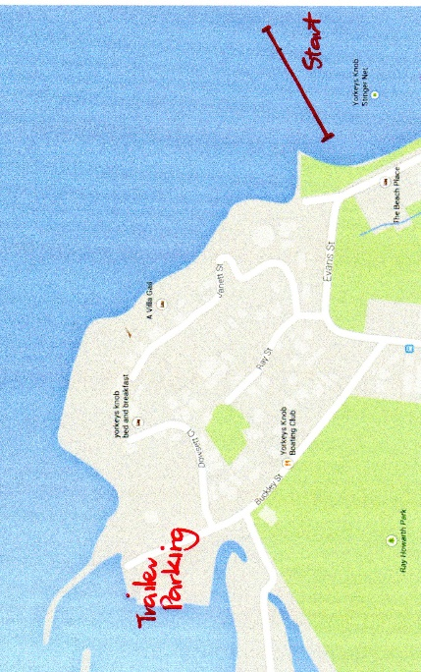
Car Parking is available at the Race start area on Sim’s Esplanade (northern end of Yorkeys Main Beach) and adjacent side streets

CANOE TRAILER PARKING PORT DOUGLAS

Canoe trailer parking in Port Douglas will be in the designated parking area at Reynolds Park off Garrick Street.
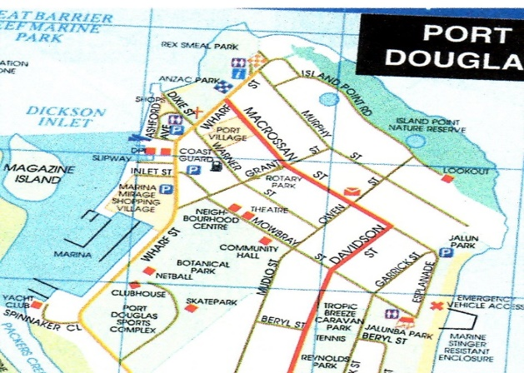
Car parking in Port Douglas is at the rear of the Port Douglas Surf Life Saving Club along the road sides and at Reynolds Park. **

Please note: parking will be very limited along Four Mile Beach and road closures may be in place.

**Please be aware of road closures on the day**

Port Douglas: Exit Captain Cook Highway into Port Douglas Road and follow all the way to Blake Street. Turn right into Blake Street and left on Garrick Street. Follow the signs into the designated car parking area.

Please follow the signs and any directions from parking marshals.

ACCOMMODATION: YORKEY’S KNOB

A wide range of holiday apartments, houses and B&B’s are available through

Yorkey’s Knob Holiday Rentals
77 Sims Esplanade, Yorkey’s Knob
Ph: 07 4055 8855 (int. +61 7 4055 8855)
Mobile: 0408 558 855
Email: trish@yorkeysknobholidays.com.au
www.yorkeysknobholidays.com.au

Follow us on Facebook: Hekili Outrigger Canoe Club Cairns

Results 2014, Photos and More: www.hekilioutrigger.com.au

Is GBROC really “the best race in Australia”?

www.youtube.com/watch?v=GiMbqHXURIA

Course Map
